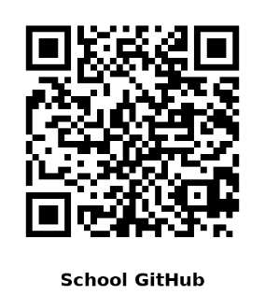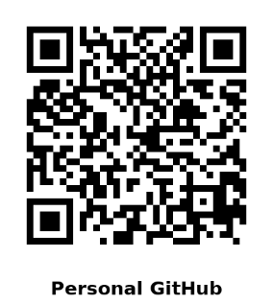Walker Stephens

**(706) 537-4716 |** [**walker_stephens@yahoo.com**](mailto:walker_stephens@yahoo.com)| [**Website**](https://walker-stephens.github.io/) **|** [**GitHub – Personal**](https://github.com/Walker-Stephens) **|** [**GitHub – School**](https://github.com/WeStephens97)

**Education**

**Dalton State College – Dalton, GA  
*Bachelor of Science in Information Technology (Expected May 2026)***

**University of Georgia – Athens, GA  
*Bachelor of Arts in History and Philosophy***

* **GPA: 3.62**

**Technical Skills**

**Programming & Databases: Java, Python, Kotlin, SQLite, SQL  
Version Control: GitHub (Personal and Academic repositories) and Git  
Operating Systems: Windows 11 (daily use), Linux (pentesting and troubleshooting)  
Networking: Cisco devices, switch and router configuration, OSPF routing, VPNs, IP/DNS troubleshooting, connectivity resolution  
Microsoft 365 / Windows Environment: Troubleshooting Outlook, Word, Teams, and Windows systems  
Customer Service: 10+ years’ experience supporting diverse customer bases, including academic end users and retail/food service clients**

**Professional Experience**

**Dalton State College – Dalton, GA  
*Help Desk Technician (Tier 1 Support)* | May 2024 – Present**

* **Provide first-line technical support for faculty, staff, and students via phone, email, and walk-up.**
* **Diagnose and resolve account login issues, Microsoft 365 errors, and general system malfunctions.**
* **Document incidents and solutions in SharePoint ticketing system; escalate complex cases to higher-level teams.**
* **Guide users through troubleshooting steps with a customer-first approach, ensuring minimal downtime.**

**Key Achievements:**

* **Identified and reported a bug in Dalton State’s integrated OneLogin password reset process.**
* **Helped uncover errors on the student password reset webpage, enabling system-wide correction.**
* **Resolved 26% of incoming tickets for my department.**
* **Recognized for clear communication and problem-solving skills that improve user satisfaction.**

**Projects**

* **Linux Security Lab – Configured a Linux VM for penetration testing and vulnerability analysis.**
* **Networking Lab – Configured Cisco routers and switches with OSPF routing protocol for simulated enterprise setup.**
* **Android Apps – Developed multiple apps using Android Studio.**

**Additional Highlights**

* **Currently pursuing a third bachelor’s degree in Information Technology after successful academic and career transitions.**
* **Strong academic background with high GPA and dual humanities degrees supporting analytical and critical thinking.**
* **Strong communication and user training experience.**
* **Ability to explain technical solutions to non-technical users.**
* **Proven patience and problem-solving under pressure.**